Project Report
Course Name: Object Oriented Programming (OOP)
Project Title: STUDENT ATTENDANCE MANAGEMENT SYSTEM
Student Name: Ritika Gupta
Roll Number: 55
Instructor Name: Dr. Swagatam Basu, Dr. Susovan Jana, Dr. Soumadip Biswas
Semester: Spring 2026

2. Problem Statement
In many educational institutions, attendance tracking is still performed manually using paper registers or basic spreadsheets. This traditional approach is time-consuming, error-prone, and lacks real-time accessibility. Manual systems make it difficult for instructors to accurately calculate attendance percentages, identify students with low attendance, and generate meaningful reports efficiently.
Additionally, these methods do not provide structured data management or automation, leading to inconsistencies and increased administrative workload. There is also a lack of flexibility in tracking different attendance statuses such as present, absent, or late, which limits the system’s effectiveness in real-world scenarios.
To address these challenges, a Student Attendance Management System is required that provides a structured, automated, and efficient way to manage attendance records. The system should allow instructors to add and manage student data, record attendance using multiple statuses, automatically calculate attendance percentages, and generate detailed reports.
The proposed system is designed using object-oriented programming principles to ensure modularity, reusability, and maintainability. It also incorporates data persistence to store records across sessions, along with proper input validation and error handling to ensure reliability. This system aims to improve accuracy, reduce manual effort, and provide better insights into student attendance patterns.

3. System Design

UML Diagram:
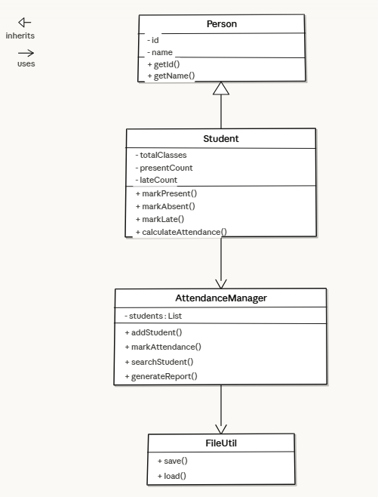

Major Class Description
1. Person Class
The Person class is the base class that contains common attributes such as student ID and name. It provides basic getter and setter methods. This class is used to demonstrate inheritance, allowing other classes to reuse common properties.
2. Student Class
The Student class extends the Person class and includes attendance-related attributes such as totalClasses, presentCount, and lateCount. It provides methods to mark attendance (present, absent, late) and calculate attendance percentage. This class encapsulates student-specific data and operations.
3. AttendanceManager Class
This class acts as the core controller of the system. It manages a collection of Student objects using dynamic data structures such as ArrayList. It provides functionalities such as adding students, marking attendance, searching students, generating reports, and checking low attendance warnings.
4. FileUtil Class
The FileUtil class handles data persistence. It is responsible for saving student data to a file and loading it when the application starts. This ensures that attendance records are maintained across multiple sessions.
Package Structure
The project follows a modular package structure to maintain separation of concerns:
1)model package: Contains core classes such as Person and Student
2)service package: Contains business logic (AttendanceManager)
3)util package: Handles file operations (FileUtil)
4)main package: Contains the entry point of the application (Main class)
This layered architecture improves code organization, maintainability, and scalability.
Interaction Flow
The system follows a structured flow of operations:
- The user interacts with the system through the menu-driven interface in the Main class.
- Based on user input, requests are sent to the AttendanceManager.
- The AttendanceManager processes operations such as adding students, marking attendance, or generating reports.
- The Student class updates attendance data accordingly.
- The FileUtil class is used to save or load data when required.
- The system displays results such as attendance percentage, reports, and warnings to the user.
This flow ensures a clear separation between user interaction, business logic, and data management.

4. OOP Concepts Demonstrated
Encapsulation
Where it is used:Encapsulation is used in the Student class where attributes such as totalClasses, presentCount, and lateCount are declared private and accessed using public getter and setter methods.
Why it is used:It ensures data hiding and protects the internal state of the object from unauthorized access or modification.
Code Snippet (Student.java):
private int totalClasses;
private int presentCount;
private int lateCount;

public int getTotalClasses() {
return totalClasses;
}

public void setTotalClasses(int totalClasses) {
this.totalClasses = totalClasses;
}
Explanation:The variables are declared as private, preventing direct access. Getter and setter methods provide controlled access, ensuring that data is modified only in a safe and valid manner.
Inheritance
Where it is used:Inheritance is implemented where the Student class extends the Person class.
Why it is used:It allows reuse of common properties such as id and name, reducing code duplication and improving maintainability.
Code Snippet (Student.java):
public class Student extends Person {

public Student(String id, String name) {
super(id, name);
this.totalClasses = 0;
this.presentCount = 0;
this.lateCount = 0;
}
}
Explanation:The Student class inherits attributes and methods from the Person class using the extends keyword. The super() call initializes the parent class properties.
Abstraction
Where it is used:Abstraction is achieved through separation of responsibilities among Main, AttendanceManager, and Student classes.
Why it is used:It hides complex implementation details and allows users to interact with only the necessary functionalities.
Code Snippet (Main.java):
AttendanceManager manager = new AttendanceManager();
Scanner scanner = new Scanner(System.in);

String FILENAME = "students_data.csv";
manager.loadDataFromFile(FILENAME);
Explanation:The Main class interacts only with high-level methods such as loadDataFromFile(). The internal logic of file handling is hidden inside other classes, demonstrating abstraction.
Polymorphism
Where it is used:Polymorphism is used in attendance marking where different behaviors occur based on the input status.
Why it is used:It allows a single method to perform different actions depending on input, increasing flexibility.
Code Snippet (AttendanceManager.java):
if (status.equalsIgnoreCase("p") || status.equalsIgnoreCase("present")) {
student.markPresent();
} else if (status.equalsIgnoreCase("a") || status.equalsIgnoreCase("absent")) {
student.markAbsent();
} else if (status.equalsIgnoreCase("l") || status.equalsIgnoreCase("late")) {
student.markLate();
}
Explanation:The same method processes different types of attendance (present, absent, late) depending on input, demonstrating runtime polymorphism.
Exception Handling
Where it is used:Exception handling is implemented in file operations such as loading student data.
Why it is used:It prevents the program from crashing and handles unexpected runtime errors gracefully.
Code Snippet (AttendanceManager.java):
try (BufferedReader br = new BufferedReader(new FileReader(filename))) {
String line;
while ((line = br.readLine()) != null) {
String[] parts = line.split(",");
}
} catch (IOException e) {
System.out.println("Error loading data: " + e.getMessage());
}
Explanation:The try-catch block ensures safe execution of file operations. If an error occurs, it is handled properly without terminating the program.
Collections
Where it is used:Collections are used in the AttendanceManager class to store student objects dynamically.
Why it is used:It allows flexible and efficient management of multiple student records.
Code Snippet (AttendanceManager.java):
private List<Student> students;

public AttendanceManager() {
this.students = new ArrayList<>();
}
Explanation:An ArrayList is used to store student objects. It allows dynamic resizing and easy iteration, making it suitable for managing collections of data.

5.Implementation Highlights
Attendance Percentage Calculation
Code Snippet (Student.java):
public double calculateAttendance() {
if (totalClasses == 0) {
return 0.0;
}
return ((double) presentCount / totalClasses) * 100.0;
}
Justification:This method calculates the attendance percentage dynamically based on the number of classes attended and total classes conducted.
Explanation:The method ensures safe calculation by handling division by zero. It converts values to double for accurate percentage calculation.
Attendance Marking with Status
Code Snippet (AttendanceManager.java):
if (status.equalsIgnoreCase("p") || status.equalsIgnoreCase("present")) {
student.markPresent();
} else if (status.equalsIgnoreCase("a") || status.equalsIgnoreCase("absent")) {
student.markAbsent();
} else if (status.equalsIgnoreCase("l") || status.equalsIgnoreCase("late")) {
student.markLate();
} else {
System.out.println("Invalid status provided.");
return;
}
Justification:This logic allows flexible input handling for different attendance statuses.
Explanation:The system supports multiple formats (P, A, L or full words). Invalid inputs are handled to maintain data correctness.
File Handling for Data Persistence
Code Snippet (AttendanceManager.java):
try (BufferedReader br = new BufferedReader(new FileReader(filename))) {
String line;
while ((line = br.readLine()) != null) {
String[] parts = line.split(",");
}
} catch (IOException e) {
System.out.println("Error loading data: " + e.getMessage());
}
Justification:This ensures that student data is stored and retrieved across sessions.
Explanation:The system reads data from a file and reconstructs student objects. Exception handling ensures reliability.
Input Validation and Error Handling
Code Snippet (Main.java):
if (id.isEmpty()) {
System.out.println("Error: Student ID cannot be empty.");
break;
}

if (manager.searchById(id) != null) {
System.out.println("Error: Student with ID already exists.");
break;
}
Justification:Prevents invalid or duplicate data entry.
Explanation:The system checks for empty input and duplicate IDs before adding a student, ensuring data consistency.
Low Attendance Warning System
Code Snippet (AttendanceManager.java):
double attendance = student.calculateAttendance();
if (student.getTotalClasses() > 0 && attendance < 75.0) {
System.out.println("Low attendance warning for " + student.getName());
}
Justification:Helps identify students with poor attendance.
Explanation:The system automatically checks attendance percentage and generates warnings, improving monitoring and decision-making.

6)Testing & Error Handling
Test Cases Considered
The system was tested using multiple real-time scenarios to verify correctness and reliability:
- Adding a new student with valid input
Input: ID = 125, Name = riya
Output: "Student added successfully."
- Adding a duplicate student
Input: ID = 125 again
Output: "Error: Student with ID '125' already exists."
- Invalid menu input
Input: non-numeric or invalid option (e.g., "maya", "127")
Output: "Invalid choice. Please try again."
- Marking attendance for existing student
Input: ID = 125, Date = 2026-03-25, Status = P
Output: "Attendance marking processed."
- Marking attendance for non-existing student
Input: ID = 127
Output: "Student not found."
- Viewing attendance report
Output: Displays student details including total classes, present count, and attendance percentage.
Edge Cases Handled
The system handles the following edge cases effectively:
- Empty student ID or name input
- Duplicate student ID prevention
- Attendance calculation when total classes is zero
- Invalid attendance status input (not P/A/L)
- Invalid menu choices (non-numeric or out-of-range values)
- Attempting operations on non-existing students
Failure Scenarios
The system gracefully manages failure conditions:
- Displays error when student ID is not found during attendance marking
- Prevents duplicate student entries
- Handles invalid user input without crashing the program
- Displays warning messages instead of terminating execution
- Skips incorrect or invalid operations safely
Error Handling Mechanism
The following techniques are used for error handling:
- Input Validation:
Checks for empty values and duplicate IDs before adding students
- Conditional Checks:
Ensures valid menu choices and valid attendance status inputs
- User Feedback Messages:
Clear error messages such as "Student not found" and "Invalid choice" guide the user
- Exception Handling:
Try-catch blocks are used for file operations to handle runtime errors
These mechanisms ensure that the system remains stable, user-friendly, and robust during execution.

7)Git Workflow
Commit History
The project was developed using Git with a total of 17 commits, following a structured and incremental development approach. Each commit represents a specific feature, improvement, or bug fix in the system.
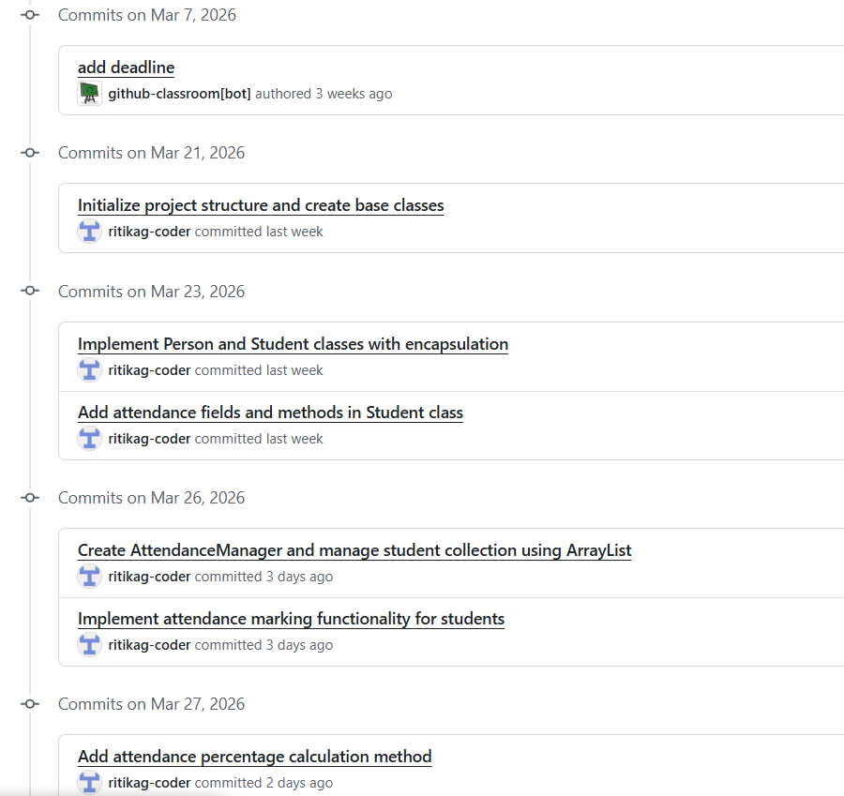
Commit History:

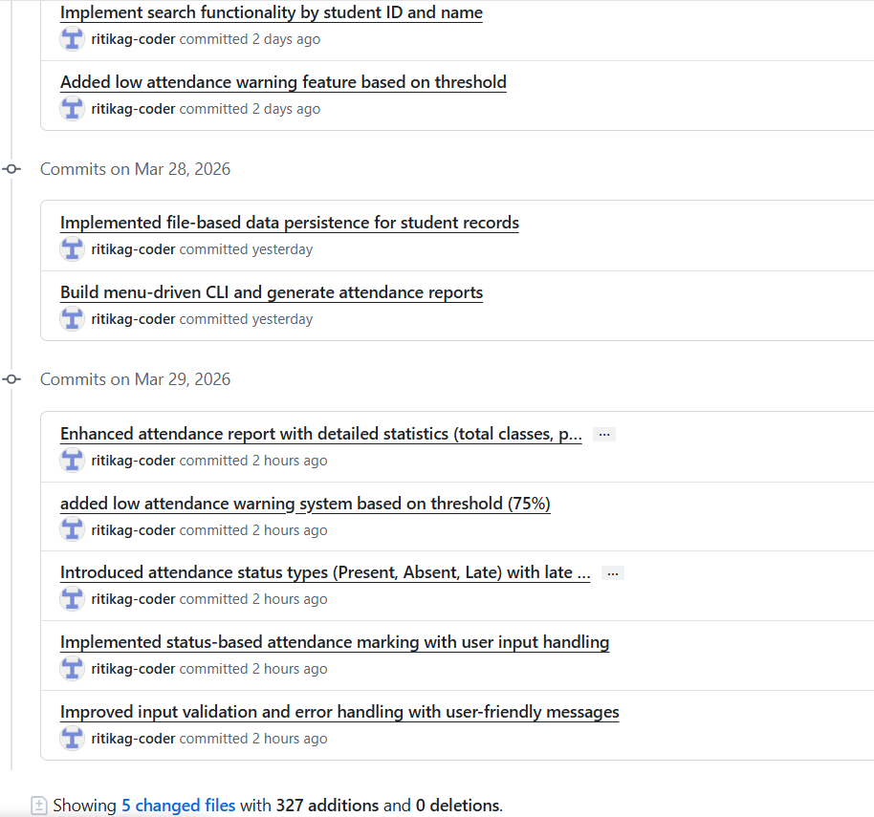

Development Progression
The development of the project was carried out in multiple stages:
- Initial Setup (Commits 1–2):
Created project structure and implemented core classes such as Person and Student.
- Core Functionality (Commits 3–7):
Implemented attendance tracking, calculation logic, and student search features.
- Feature Enhancements (Commits 8–10):
Added low attendance warning, data persistence, and menu-driven interface.
- Bug Fixes & Improvements (Commits 11–14):
Fixed issues such as duplicate student IDs, input validation errors, and file handling improvements.
- Advanced Features & Refinement (Commits 15–17):
Added attendance status (Present/Absent/Late), improved reporting system, and enhanced error handling.
Version Control Benefits
Using Git provided several advantages during development:
- Allowed tracking of changes at each stage of the project
- Enabled organized and modular development
- Made it easy to identify and fix errors
- Improved code management and maintainability
- Helped in maintaining a clear development history
Conclusion on Workflow
The use of Git ensured a systematic and well-documented development process. Each feature was implemented step-by-step, making the project easy to understand, debug, and extend.

8)Conclusion & Future Scope
Conclusion
The Student Attendance Management System was successfully developed using object-oriented programming concepts. The system provides an efficient and structured way to manage student attendance records. It allows users to add students, mark attendance with different statuses, calculate attendance percentages, and generate detailed reports.
The implementation of features such as input validation, low attendance warnings, and data persistence ensures that the system is reliable and user-friendly. The use of modular design and proper OOP principles makes the system easy to understand, maintain, and extend.
Overall, the project achieves its objective of replacing manual attendance tracking with an automated and efficient solution.
Future Scope
The system can be further improved by adding the following features:
- Development of a graphical user interface (GUI) for better usability
- Integration with a database instead of file storage
- Adding login system for teachers and administrators
- Generating advanced reports and analytics
- Integration with web or mobile applications for remote access
These enhancements can make the system more scalable and suitable for real-world applications.
Appendix
Copy of the initial project proposal
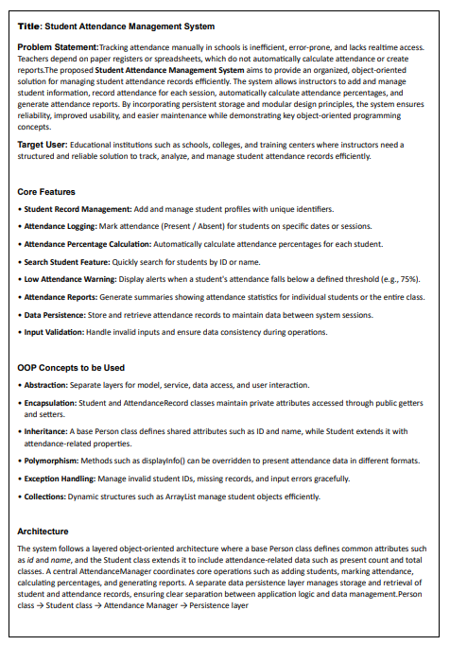

Copy of the review mail received (with APPROVED_MINOR)
